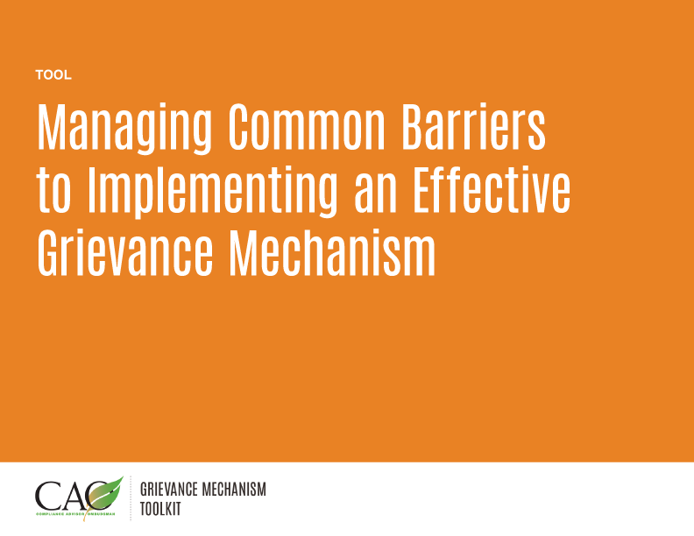

Last updated: May 2016
COMMON BARRIERS FOR COMMUNITIES | Example | Effectiveness criteria | Possible solution
Limited or unclear information about how to file a complaint.  The process to submit a grievance is inconvenient (language barriers, prohibitive costs, or difficulties accessing the system). | The Grievance Officer views complaints as negatively reflecting on his/her work performance and does not publicize the mechanism.  The grievance mechanism is located in an area of company property where a company pass is needed to access the mechanism. | Legitimate; accessible; transparent | Management encourages a culture where complaints are viewed as positive indications of stakeholder engagement.  The company periodically surveys community members to determine if they understand access points and whether they are satisfied with the grievance mechanism.
Fear of lack of confidentiality or feeling that anonymous complaints will not be heard. | Complainant fears confidentiality will not be maintained and that if identity becomes public, he/she will be targeted for retaliation. | Legitimate; rights-compatible | Management is involved in implementing the grievance mechanism, makes sure that confidentiality/anonymity are respected, and periodically monitors the status of complaints in the grievance mechanism.
Fear of negative consequences or retaliation. | Community members fear they will be targeted or denied project benefits if they file a complaint. | Legitimate; rights-compatible | The company periodically has an independent party conduct interviews with complainants after the complaint has been closed to evaluate perceptions of fairness.
Complainants view participation in the grievance mechanism as limiting their recourse beyond the grievance mechanism (that is, they believe the grievance mechanism serves as final judge and jury). | The Grievance Officer pressures or offers incentives for complainants to accept a resolution that they do not agree with.  The Grievance Officer indicates that if they use the grievance mechanism, other recourse options will not be available to them. | Legitimate; rights-compatible; transparent | Management periodically audits and/or conducts or commissions an effectiveness survey of community members who have used the grievance mechanism.  The grievance mechanism process—including opportunities for appeal or seeking alternative recourse—is clearly communicated by the company— verbally and in its written materials.
Staff bypass system and resolve issues informally, because they want to keep issues quiet or cover up poor staff performance. | A Grievance Officer has an informal agreement with the land department to resolve concerns about access to land with cash payments to community members from an unmonitored account. | Legitimate; accessible; predictable; equitable; rights-compatible; transparent; continuous learning; derived from community-based agreement | Eliminate Grievance Officer access to cash accounts.  Require documentation and approval by management for any payments.
Lack of follow-through on commitments made by staff.  Delay(s) in implementation of resolution. | The Grievance Officer offers to repair a damaged area with company equipment to resolve a complaint. The manager does not approve the use of the equipment for several months, because it is being used for a construction project. | Legitimate; predictable; transparent | Specify clear timelines that can be altered only if the appropriate manager agrees and the complainant has been consulted.  Make sure the operations manager is committed to the grievance mechanism.
No champion at the management level to drive accountability.  Limited buy-in from staff beyond the community engagement unit. | Management views community complaints as a negative mark on their performance and encourages the Grievance Officer to “just sort things out informally with community members.” | Legitimate; continuous learning | Encourage reporting of complaints at the highest level of the organization.  Make the grievance mechanism a part of management’s performance review.

The Effectiveness Criteria are set out in the UN Guiding Principles on Business and Human Rights, Implementing the United Nations “Protect, Respect and Remedy” Framework, United Nations, New York and Geneva, 2011, (http://www.ohchr.org/Documents/Publications/GuidingPrinciplesBusinessHR_EN.pdf)

